
Development Request
Aria Systems
Invoice Sales order By Back Flushing

January 17, 2005

New Form Template Description

Form Template

Template Header
Product: | Aria 2.7.
Module: | AR
Customer name: | Planet Distribution
Program Name: | Sales Order Invoice
Form Name:
Installed Modules: | AR, IC, SO,PO,SA,RM,SM,MA,
Parameters setting: | Multi-currency = Y  Multi-warehouse = Y  Material Costing method = Lot  Style Costing method = Average  Extended sizes = No  Style structure = 12 chars for style, 6 for colour

System Setting Report:
Planet distribution buy plain short sleeve tee shirts, sweatshirts etc. Then they design transfers that are ironed on to the plain tee shirts, you can buy an plain garment with any transfer iron on operation is competed in there warehouse.

The Idea behind this program is:
Sales order generated, Print order confirmation, send order confirmation to warehouse, they then get the plain garment and the transfer and iron the transfer onto the shirt, they mark the order confirmation to note that the item is made and ready to send to the customer.

At this point they want to be able to invoice the garments but do not want to go thru the procedures of generate PO, issue PO cost sheet, Receive PO, Pick Order. As this is taking up far too much time.

This Program will be called Direct Sales order invoice
It will be located in AR, Transaction, Invoice sales order select the sales order, Options, Direct Sales order invoice

The Purpose of this program is to automatically create an invoice the same as the invoice sales order program, but additionally it will create an issue record in the matinvjl file for the items that are in the BOM file, it will also automatically generate a + adjustment record in the styinvjl file and when the invoice is saved it will generate a – invoice record.

Program Instructions

Create a screen the same as the Invoice sales order and call it Sales order invoice
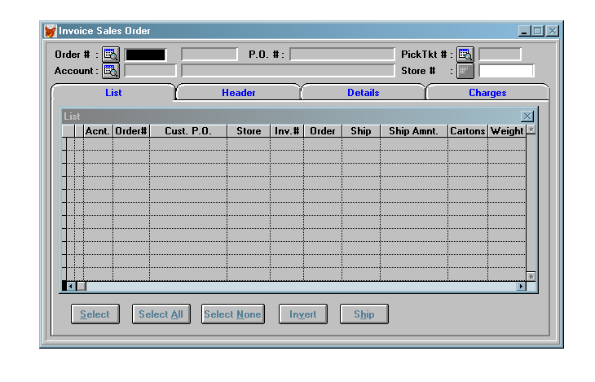
- The order browse this should only bring up order that have status O they will select the order number that they want to invoice, you will bring the order in to the list screen.
- Account browse this should bring up the customer standard browse, once a customer is selected they will select the order the browse should only show order for the selected customer with status ‘O’
- There should NOT be a Pick Ticket browse
Scenario 1
Invoicing sales orders
Once the order has been selected they can then go to the detail screen and they can then select the styles and quantities that they want to invoice

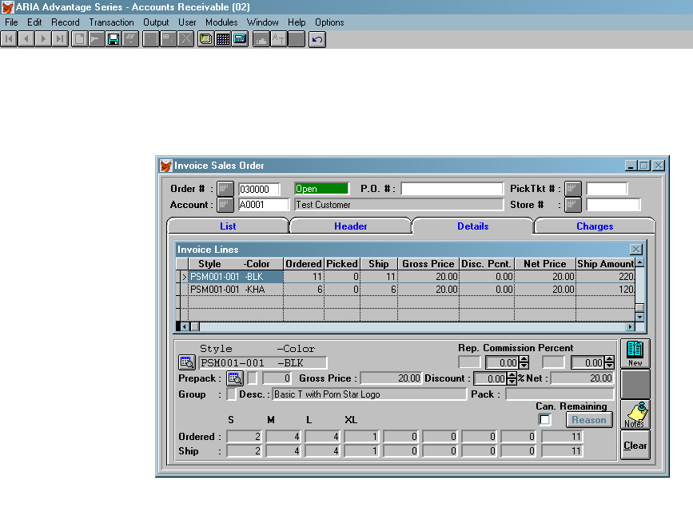

Before any transactions are created please look at the inventory (stk-alo) of the style/colour/size on the sales order if there is any physical stock please use these first
Create normal invoice records for these in the styinvjl records.

The matinvjl file needs to be updated so that the material stock is taken out for the garments that have been saved
PSM001-001 -BLK 2 4 4 1
PSM001-001 -KHA 1 2 2 1

You need to use the same calculations as if you had generated a PO SO to create a ctktbom by looking at the bom file,

So in the case above

Fabric T001S BLK –2 Tran Ctrantype 2 and Ctran 030000
Fabric T001M BLK –4 Tran Ctrantype 2 and Ctran 030000
Fabric T001L BLK –4 Tran Ctrantype 2 and Ctran 030000
Fabric T001XL BLK -1 Tran Ctrantype 2 and Ctran 030000
Fabric 001 WHI –11 Tran Ctrantype 2 and Ctran 030000
Fabric T001S KH –1 Tran Ctrantype 2 and Ctran 030000
Fabric T001M KHA –2 Tran Ctrantype 2 and Ctran 030000
Fabric T001L KHA –2 Tran Ctrantype 2 and Ctran 030000
Fabric T001XL KHA –1 Tran Ctrantype 2 and Ctran 030000
Fabric 001 YEL –4 Tran Ctrantype 2 and Ctran 030000

The Styinvjl File needs to be updated with + entries and – entries so that the stock figures are correct

Example
Invoice 060000 has the following styles on it from order 030000

S M L XL
PSM001-001 -BLK 2 4 4 1
PSM001-001 -KHA 1 2 2 1

So in the above case the new + styinvjl records need to be created are

S M L XL
Style PSM001-001 -BLK 2 4 4 1
CTRTYPE 1 CTRCODE 030000 Reference Cust#A001 Sales order 030000
Style PSM001-001 -KHA 1 2 2 1
CTRTYPE 1 CTRCODE 030000 Reference Cust#A001 Sales order 030000

Then there needs to be a – entry to deduct the stock

S M L XL
Style PSM001-001 -BLK 2 4 4 1
CTRTYPE 1 CTRCODE 060000 Reference Cust#A001 Sales order 030000
Style PSM001-001 -KHA 1 2 2 1
CTRTYPE 1 CTRCODE 060000 Reference Cust#A001 Sales order 030000

You must also update the stydye and style with the relevant information. So that the balance of the order that was places is all that shows.

They will then click on the charges tab and add any charges to the invoice then they will save the invoice and this will update Invhdr and Invline and Invchrg files and generate an invoice number as the standard invoice program

